STRATEGIC HEALTH PURCHASING AND PROVIDER PAYMENT MAPPING ASSESSMENT PROTOCOL
EHIA, USIAD/HFIP

Contents
Assessment Goal, Objectives and Outcomes 3
Goal 3
Primary Objectives 4
Assessment outcomes 4
Methodology 4
Study design 4
Study area and sample 4
Study Team 5
Study Procedures 6
Recruitment Process 6
Data collection methods 6
Data Analysis 6
Ethical consideration 7
Result dissemination 7
Annex 7

Introduction
Ethiopia is committed to achieving universal health coverage (UHC). This commitment has led to investments in improving access to equitable, quality health services and reducing financial barriers to accessing health services through a series of health financing reforms. One of these key reforms was the establishment of community-based health insurance schemes (CBHIs) and the planned development of social health insurance (SHI) to provide access to primary health care as well as higher levels of care. While the CBHI targets the informal and rural sectors, the SHI is intended to target the formal sector. The Ethiopia Health Insurance Agency (EHIA) was established to coordinate and regulate health insurance in the country and lead implementation of CBHI and SHI.
CBHI was initiated as a pilot in 2011 in 13 Woredas/districts and has been scaled up to 869 Woredas covering nearly 38.8 million beneficiaries. CBHI has seen remarkable improvements in increasing access and financial protection of households but faces financial sustainability challenges. SHI is yet to be established and its rollout has been delayed due to a number of challenges. However, most of the preparatory activities have been completed (legal framework is ratified, agency established, branch offices opened, staff deployed).
Within its mandate of providing coordination and regulation of the CBHI and SHI in Ethiopia, EHIA is exploring strategies to improve the working on value for money for the CBHI scheme and move from passive to strategic purchasing. One of the strategies being applied by EHIA is the planned pilot of capitation payment for PHC to strengthen provision of PHC and contain costs. In addition, as EHIA prepares to set up the SHI, several lessons can be borrowed from CBHI, to ensure SHI is set up more efficiently and sustainably.
Accordingly, EHIA in collaboration with USAID/HFIP and The Strategic Purchasing Africa Resource Centre (SPARC), among other stakeholders, have planned to do a mapping of Ethiopia’s purchasing arrangements and scoping review to prioritize and clarify the vision of the strategic purchasing institutional arrangements, functions, policies and operating systems that work together to achieve agreed objectives.
The assessment not only aims to report where Ethiopia is in the journey of moving from passive to strategic health purchasing but also aims, to identify and analyze opportunities, critical barriers, and facilitators in implementation of strategic purchasing for Ethiopian health insurance program.
The Strategic Purchasing Africa Resource Centre (SPARC) developed the strategic purchasing progress tracking framework to understand how strategic purchasing leads to better performing health systems. The framework is based on the premise that a strong strategic purchasing system has a set of core functions: financial management, benefits specification, contracting arrangements, provider payment, and performance monitoring. These functions are supported by clear institutional arrangements that allocate responsibility for carrying out the functions and by governance structures that provide oversight, accountability, and reporting lines and ensure effective stakeholder participation. (See Figure 1.) The core purchasing functions are carried out through strategic, objectives-driven policies and strong, preferably automated, operating systems. The power of strategic purchasing to achieve health system outcomes is either enhanced or limited by the governance arrangements and a set of external factors. This framework has been applied in nine African countries and provides a system-wide view of purchasing functions of health financing arrangements, where there are duplications, conflicts and overlap, and where there are opportunities to improve purchasing functions.

Figure 1. Strategic Health Purchasing Progress Tracking Framework
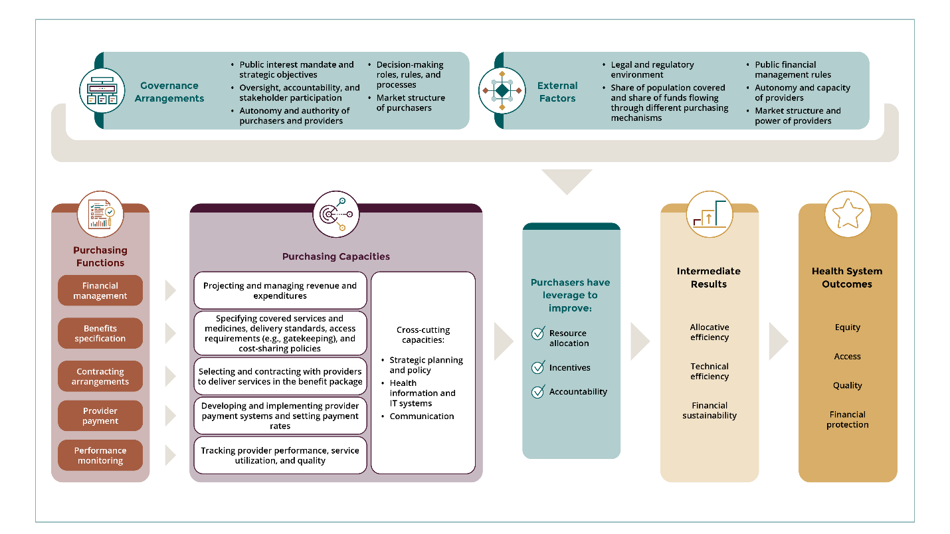

This assessment will apply the framework to assess and document purchasing functions in Ethiopia’s main health financing schemes and to derive inputs and a roadmap that will be used to inform stakeholder conversations on how Ethiopia can become a better strategic purchaser. This assessment will also include a deep dive into the current provider payment mechanisms in use and their ability to provide the right incentives for access, equity, quality and efficiency in service delivery among providers.

Assessment Goal, Objectives and Outcomes

Goal
To assess the strategic health purchasing arrangements in the major health financing schemes in Ethiopia (e.g Federal Ministry of Health (FMOH) and CBHI) and conduct an assessment of provider payments to give insights to how they are working and what needs to be improved or strengthened.

Primary Objectives
- To document the current purchasing functions and governance arrangements in the major health financing schemes
- A high-level review of provider payment in Ethiopia for insights into how they are working and what needs to be improved or strengthened
Secondary Objectives
- Understand key stakeholders of strategic health purchasing and how they relate to each other.
- To identify opportunities, barriers, facilitators and actionable steps that can be taken to lay a foundation for strategic health purchasing
- To provide inputs into a country dialogue and a roadmap for implementing strategic health purchasing in Ethiopia
Assessment outputs
- SHP assessment report validated by TWG validated report on purchasing arrangements in Ethiopia
- Validated strategic purchasing action plan and implementation roadmap
- An assessment report detailing Ethiopia’s purchasing arrangements and priorities for improving strategic purchasing

Assessment outcomes
The outcomes of the assessment will be based on the objectives. They are creating a shared understanding of the current purchasing arrangements for the two major schemes and consensus on how to make progress on strategic purchasing

Methodology

Study design
This study is an assessment of Ethiopia’s status on strategic health purchasing. Modes of data collection will include:
- A desk review of relevant policy and program documents relating to strategic health purchasing in Ethiopia, and other relevant documents.
- In-depth interviews (FGD and KII) will be conducted with key stakeholders for strategic health purchasing including policy makers, programme managers and other relevant stakeholders.
- Quantitative purchasing data will be collected from all sub-national units who oversee purchasing in Ethiopia.

Study area and sample
This study will be conducted in Ethiopia. A purposive sampling methodology will be used to select participants for the in-depth interviews. Quantitative data on the health financing schemes present in Ethiopia at the national and sub-national levels will also be collected as secondary data using the SPARC strategic health purchasing descriptive tool and the Joint Learning Network Provider Payment Mechanism (PPM) toolkit.
Inclusion criteria: Participants eligible for this study will include health purchasing stakeholders in Ethiopia including policy makers, program managers (government and development partners), donors, Civil Society Organizations and other relevant stakeholders.
Exclusion Criteria: Stakeholders who do not have any strategic health purchasing experience

Study Team
The study will be undertaken by local consultants hired by SPARC under the oversight of the strategic purchasing technical working group. The table below summarizes the roles of the key personnel involved in the study
Individual/Group | Roles
Technical working group | - Acting as a technical clearing house, the TWG works closely to ensure that all mapping activities are performed as per plan  - Provide technical input and assistance and overall guidance during of strategic purchasing assessment, review, reporting, adaption, developing roadmap and plan.  - Support activities of EHIA to mobilize resources to enhance implementation of developed roadmap.  - Periodic review the implementation performance of the roadmap and plan.  - Support monitoring and continuous progress assessment of the implementation of roadmap  - Validate findings from the assessment and the study report  - Facilitate operational activities when needed (Ethical clearance)  - Facilitate the shortlists of stakeholders for qualitative interview and introductions of the stakeholders to the local consultants.
EHIA | - Review the study protocol and approve the protocol  - Approve the study report  - Facilitate operational activities when needed (Ethical clearance)  - Facilitate the shortlists of stakeholders for qualitative interview and introductions of the stakeholders to the local consultants.
SPARC consultant | - Finalize study tools  - Conduct data collection including the key informant interviews, based on TWG direction  - Populate the tools  - Lead analysis and report writing  - Capture and document minute in collaboration with TWG  - Continuously update and present activity progress for TWG  - Majorly perform as TWG direction and activity distribution

Study Procedures

Recruitment Process
Major activities will be carried out by establishing a Technical Working Group (TWG) which would be led and coordinated by EHIA’s Provider Affairs and Quality Assurance Directorate (PAQAD). Throughout the process the task will be guided, coordinated and led by EHIA senior management and PAQAD. Participants will be selected purposively by the TWG and EHIA who will inform the participants of the assessment and facilitate an introduction to the local consultant. All participants will be required to give informed consent prior to commencement of interviews.

Data collection methods
Two tools will be developed for the data collection process by the strategic health purchasing Technical Working Group (TWG) who will oversee the assessment process. The tools will include:
- The qualitative interview guide for interviewing key stakeholders for PPM– this will leverage on the module 1 and 2 of the Joint Learning Network toolkit for assessing health provider payment systems.
- The quantitative tool for collection of strategic health purchasing information at the national and sub-national levels – this tool will leverage on the strategic health purchasing descriptive analytical tool developed by Results for Development and SPARC. The quantitative tool will collect secondary data from existing health financing policy and programme documents in Ethiopia. The tool will be adapted to suit the Ethiopian context.
The qualitative interview guides will be administered to eligible participants by the local consultants. The qualitative interviews will be recorded and transcribed. Qualitative data from the observation notes, discussion and interview transcripts and program documents will be systematically sorted using directed content analysis.

Data Analysis
The consultant will conduct an analysis of all the data collected using appropriate methods for qualitative and quantitative data analysis. The constant comparison analytic method will be used to analyze the interviews. This method comprises three stages, namely, open coding (summary of similar responses and ideas), focus coding (grouping responses under major/broad topics) and axial coding (emerging themes from data) (Strauss & Corbine, 1998). Microsoft Excel software will be used for organizing and analyzing qualitative data for this analysis.

Ethical consideration
The study will be conducted after ethical approval is obtained from appropriate institutions. The protocol will be submitted by EHIA for approval. Informed consent will be obtained from all persons who voluntarily agreed to be interviewed. In addition, both the quantitative (secondary data) and qualitative data collection and analysis process will be ensuring the confidentiality of all participating interviewees using de-identification of personal identifiers and only de-identified demographic information will be used during data analysis process.
No personal identifiers will be collected for in-depth interviews. Prior to the interview, the interviewer will ask for written permission to interview the participant and whether if it would be acceptable to audio record the conversation. If the interviewee declines to be recorded, the interviewer will take notes instead. All interviewees will have an option to answer or not answer any question. Interviewees may also discontinue their participation at any time during the interview process. Study research team members will either conduct or supervise all the interviews to ensure adherence to the research protocol and oral consent guidelines.

Result dissemination
Findings from this assessment will be validated by the TWG in charge of the assessment in a validation meeting. The validated findings will be collated in an assessment report, a policy brief and a PowerPoint presentation which will be shared to all relevant stakeholders including policy makers, partner organizations, donors, among others in a validation meeting.

The TWG will ensure the findings will be used to advocate for policy formulation, strategy designing and model development. They will also work to ensure that the findings will be published in peer reviewed journals to reach a wider scientific community.

Annex
Data collection tool
- Joint Learning Network toolkit for assessing health provider payment systems.
- SPARCs strategic health purchasing descriptive analytical tool
Instructions for both FGD and KII:
- The in-depth interviews should be conducted in a quiet setting.
- The in-depth interviews should be conducted by a facilitator assisted by a note taker who will take notes during interview.
- An audio recorder will be used to record the proceedings.
- Before commencing discussion patients need to voluntarily offer written consent
Check informed consent: YES NO
Time Table should be prepared for the assessment

