SEEMS-Nutrition Guidance document: Introduction and overview of the activity tracking sheet

This guidance document has been designed to support in-person training. Users can refer to this document post-training.

Overview of the Activity Tracking Sheet

The activity tracking sheet was created to support the early steps of a costing analysis of an intervention. The purpose of this tool is to aid researchers or others conducting the costing work to better understand the components and activities of an intervention. This is a helpful step in the costing process, as it ensures that researchers capture all the program components that need to be costed. The activity tracking sheet is a useful tool to describe discrete activities by sector, and to identify those activities that may be shared as part of a larger intervention or program.

There are two important objectives for filling out the activity tracking sheet for your intervention. First, the activity-tracking sheet is to identify the full range of intervention activities to map them to a smaller set of generic SEEMS-Nutrition activity categories. Despite differences in program designs and objectives, there is a similar sequence and type of activities common to most multisectoral nutrition interventions. Programs are typically described, planned, and implemented using activities as part of an operational framework. Thus, activity breakdowns better reflect multisectoral nutrition program design. The SEEMS generic set of activities was selected after comparing the activities across the five SEEMS-Nutrition country case studies. Second, the activity-tracking sheet is designed to help you pick the most appropriate cost data collection approach for your needs.

There are 4 initial worksheets (each represented as a separate tab in the Activity tracking sheet Excel document) as shown in Figure 1.

Figure 1. Overview of Activity tracking sheet

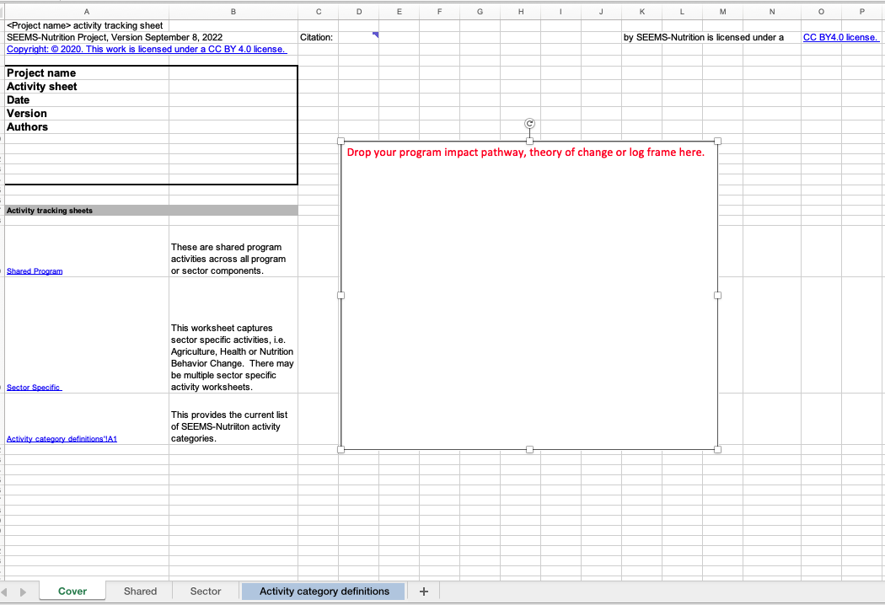

The activity tracking sheet may have 4 or more worksheets (tabs), as follows:
- The cover sheet describes the contents of the excel document (project name, date, version, authors, etc.) and provides a place to copy an image of your program impact pathway, theory of change or log frame in order to visually depict the broad intervention activities.
- There is a shared program worksheet that provides a list of activities that are common across all program or sector components (for example, planning is an activity that often occurs across all components of an intervention).
- There is one or more sector-specific worksheets that list the activities by sector, i.e. agriculture, health, nutrition, livestock, fisheries. This is important for multisectoral programs as they typically involve activities that engage distinct sectors. The user can create one worksheet per sector. For example, if the program combines agriculture, health and nutrition activities, there could be three worksheets in the document (Sector – agriculture, Sector – health, Sector – nutrition).
- A list of SEEMS-Nutrition activity categories and definitions. This list provides detailed explanations and serves as a reference when you are aligning your intervention activities with the SEEMS standardized activities and inputs.

How to get started

During the planning phase, prior to the development of a costing protocol, sit down with implementing partners or the evaluation team and start to understand the main activities associated with the program, project, or intervention. Ask to see the results framework, a program impact pathway, or any appropriate schematic showing activities to impact that may be available from project reports. The goal is to arrive at a list of all the key activities implemented as part of the program or intervention.

You can start with either the shared program or sector specific activity worksheet:
- Shared program activities may include planning, awareness raising, development of materials relevant for the entire program, coordination, integration, management, supervision, and training, where relevant.
- Sector specific activities related to agriculture, health, nutrition, WASH, gender, for example.
  - Duplicate the ‘sector’ tab and create one tab per SECTOR

The shared program and sector specific worksheets follow the same general format. Table 1 outlines the content of each column, entry, and description for the worksheets. We provide step-by step guidance on how to use the worksheet below. In practice, filling out the activity tracking sheet may be an iterative process conducted in collaboration with others on your project or evaluation team.

Table 1. List of columns for SEEMS-Nutrition activity tracking program and sector worksheets.

Column | Entry | Description
A | List activities | List activities that align with your program impact pathway; use sub-headers as needed
B | Exclude activity | Exclude research activities, international travel, international meetings that are not essential to the installation and implementation of the intervention activities. Indicate with an ‘x’ if the activity is to be excluded from the cost analysis.
C | Map to SEEMS-Nutrition activity codes | Use the dropdown menu to map the activity to the SEEMS-Nutrition standard activity codes.
D | Time period of activity | Indicate the general start and end time that the activity occurred
E | Indicate if an integration activity | Optional: Some activities are intentionally integrated to reinforce messages and actions for the intervention. If the user is interested in capturing this aspect of multisectoral programs, place an ‘x’ if the activity is essential for integration. If there are activities related to integrating planning or service delivery across sector, add activities to the ‘Shared’ worksheet tab.
F-G | Cost type category (Start-up or recurrent) | Indicate if it is a start-up or recurrent activity, place an ‘x’ in the appropriate column.
H-J | Source of expenditures | List all the organizations that either fund or finance implementation of the program. You may need to list multiple sources (i.e., if there is an activity supported financially by two different NGOs or organizations). For each activity, or for clusters of activities, indicate ‘F’, if there is a financial expense.
K-L | Shared program or donated/volunteer goods and services | Indicate ‘E’ if there is an economic cost. An economic cost is the value of any resources used for implementing the program that is NOT covered in the financial costs and may include donated goods or volunteer time.
M | Indicate if beneficiaries participate in the activity | Indicate ‘x’ for activities where beneficiaries (mothers and their children under 2 years) participate. The purpose of this action is to help identify where participants incur economic costs so those costs can be captured in cost estimates.
N | Indicate the types of NGO staff, frontline workers and public or private sector partners implementing these activities | List the types of program implementers (community health workers, health volunteers, governmental partners, such as extension workers), that implement each set of activities.

Step 1: Start by describing activities in Column A.

When you begin use of the activity tracking sheet, it is useful to gather key program documents for the intervention you are costing. Program documents from the implementer should contain detailed descriptions of implementation activities at all levels (household, community, etc.). You may even find it helpful to first list these broader activity categories. For example, you can start with the worksheet by outlining these broad sectoral clusters of activities, such as increasing agriculture production, implementing nutrition behavior change communication and agriculture.

Remember to create different worksheet tabs for each sector. In each sector worksheet, provide discrete activities for the project chronologically as you work through and list the activities. It is recommended to begin listing activities with start-up activities. Start-up activities are those needed to plan, install, and implement the program or intervention. After listing the start-up activities, continue to list the on-going recurrent implementation activities. See Figure 2 below.

Verify that you have captured all activities associated with the intervention by reviewing program documents from the implementing organization. You can always return to the activity tracking sheet to add in activities in real time in case you discover additional activities that you may have overlooked. On occasion, there may be activities that are not clearly explained or included in the program documents. Engagement with program implementers - whether through email, phone, or other communication - can be helpful to clarify which activities were implemented in practice as well as identifying any activities that were added after the program was designed, or that you were not able to capture using documentation.

Step 2: Indicate if the activity should be excluded from the cost analysis.

Depending on your study objectives, it often makes sense to exclude external research activities, such as baseline surveys, endline surveys, or process evaluations. If the research activity is essential for the intervention, i.e., a consumer acceptance study, or research informing project design or components, it should be included. However, you should exclude evaluation or research that is not directly used for program implementation purposes. You should also exclude larger program activities that are not directly related to reaching the coverage or health outcome objectives of the intervention. See figure 2 below. One example of this is international travel to a conference. Any excluded activities should be carefully recorded and justified.

Figure 2: Listing activities in column A of the sector worksheet.

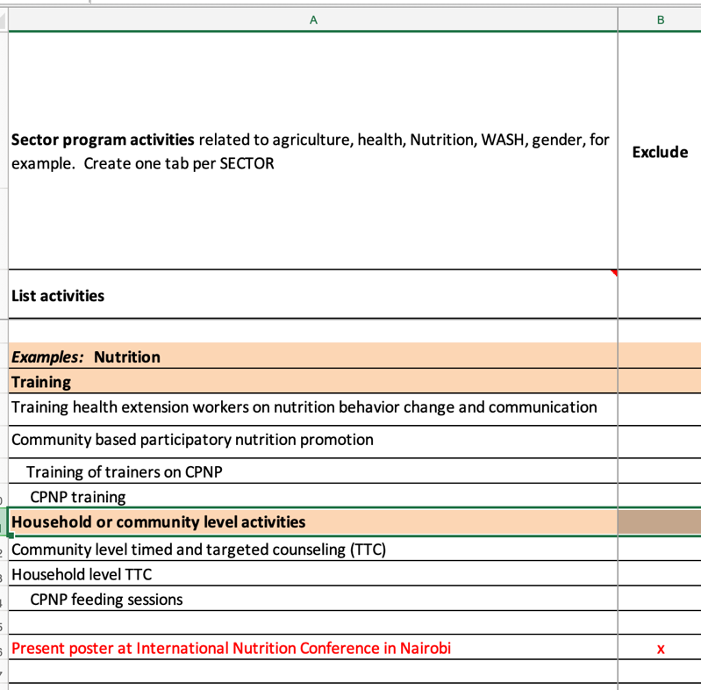

TIP: Try not to go into too much detail (but provide just enough detail) to map to a broader SEEMS Nutrition Activity code.

Step 3: Map the activities in column A to the SEEMS-Nutrition Standard activity codes.

The SEEMS Nutrition activities codes are listed in the last worksheet called ‘Activity category definitions”.

Table 2: List of columns for the SEEMS-Nutrition ‘Activity category definitions worksheet’
Column | Entry | Description
A | SEEMS Nutrition activity code | Lists the standardized activity category for (1) start up; and (2) recurrent or ongoing activities.
B | Definition | We provide a description of the types of activities that may be included within the standardized activity code.
C | Notes specific to your project | We recommend that the user indicate what the specific activities are for your program, project, or intervention, especially if they are very different from what is listed in the SEEMS standardized activity descriptions.

The standard set of activity categories can increase the comparability of cost studies across a range of multisectoral nutrition approaches. Despite differences in program designs and objectives, there is typically a similar sequence and categories of activities common to most multisectoral nutrition interventions. Programs are typically described, planned, and implemented using activities as part of an operational framework and activity breakdowns better reflect the design of multisectoral nutrition programs. This generic set of program activities has been selected after comparing the activities across five SEEMS-Nutrition country case studies. For application to new studies of multisectoral programs, these standardized activity categories may need to be modified. Examples of potential modification is for programs that have social safety net programs (cash or in-kind transfers), WASH interventions, or school feeding programs.

In general, however, the rule of thumb is that the user should work with the list of SEEMS activity codes. In most cases, a subset of these activities or slight modifications of current activity categories will be relevant across a wide range of multisectoral programs. The rationale for using the standardized codes is that it facilitates comparisons across diverse interventions. If you create too many unique activity codes, it may become difficult to understand the activity costs align with other programs. Ultimately, this is the goal and purpose of the standardized approach - thus, using our templates and standardized approach will aid comparisons and avoid many methodological challenges in cost comparisons of complex interventions. See Figure 3.

Figure 3: Mapping your activities to the SEEMS-Nutrition standard activity codes.
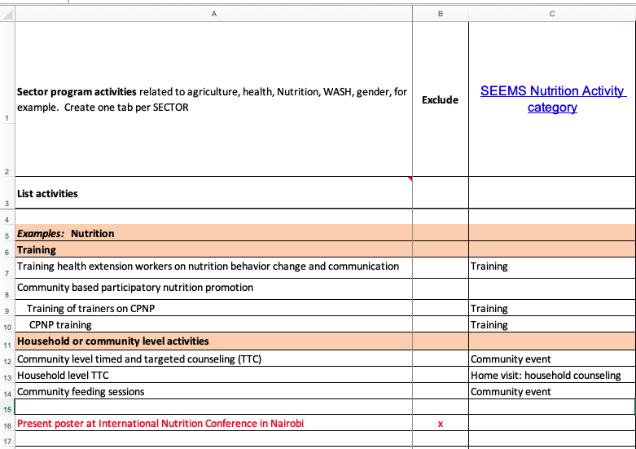

Step 4: Indicate if the activity is essential for integration across program components.

Some programs are intentionally designed to coordinate across stakeholders, sectors, and discrete program components to reinforce key messages, practices, and actions for the intervention. If the user is interested in capturing this component of multisectoral programs, place an ‘x’ if the activity is essential for integration. This is an optional step.

Step 5: Indicate if the activity is a start-up or on-going/recurrent activity.

The SEEMS-Nutrition project recommends categorizing costs as start-up and recurrent, as this is relevant for how multisectoral nutrition programs are typically implemented. The start-up period captures one-time activities like planning/micro-planning, awareness raising and sensitization, program installation, recruitment training, and materials development. These are typically activities that occur before the program can begin. Their costs will be spread over the number of beneficiaries reached throughout the project period (and sometimes beyond). Start-up costs are like a type of fixed costs since most start-up costs do not vary in the short run- they ‘fixed’ or one time in nature-and typically these costs do not vary with program scale (changes in output).

Recurrent activities capture intervention activities (at all program levels, i.e. as applicable to headquarters, regional offices and frontline workers) that are needed to reach beneficiaries. Recurrent costs also include day-to-day, weekly, monthly, or quarterly activities related to management, monitoring and evaluation and site supervision. At the community or household level, these include distribution of inputs, home visits, health facility counseling and support, community events, establishing and running community groups, microcredit activities and certification or marketing activities. Integration and coordination and overhead are considered recurrent ‘activities’ that are relevant to the overall program, even though they don’t fit neatly into one activity category. Recurrent costs can be both fixed and variable costs. For example, community outreach may require a vehicle (capital/fixed cost), as well as variable inputs, such as fuel, per diems and supplies (variable costs).

There are some recurrent activities that may have been intended to be one-time only, but were repeated once the project was up and running. For instance, programs may offer refresher training courses or community sensitization activities that are repeated over time. These activities occur as part of program implementation course correction to help improve the supply and demand of the intervention or program. Refresher trainings and community sensitization can be treated as fixed costs even when they occur after the initial start-up period, assuming their effect will last beyond one year.

Step 6: List the sources of expenditures and any shared program resources.

In this step we want to understand who is paying for the activity, who is implementing the activity and whether any costs are incurred. We want to capture shared program costs contributed by any participating government agency. We also want to capture time and costs contributed by volunteers. We want to know whether beneficiaries participate in the activity. Depending on the objective of the cost analysis, we may want to capture financial costs only, economic costs only or all types of costs, i.e. both financial and economic.

- First, list any organization that funds and/or implements the program, project, or intervention. There may be a prime funding source as well as sub-award organizations. This often occurs with NGOs, where one organization is the “primary” and another NGO or set of NGOs are sub-grantees and receive sub-awards. It is important to include both primary and sub-award organizations. Indicate an ‘F’ for any organization that has financial expenses related to the specific activity or set of activities.
- Next, we want to capture any organization or community that provides or donates time, goods or services. These may be one or more government ministries or community volunteers. Indicate an ‘E’ for any shared government involvement or community volunteers.
- Lastly, indicate which activities the program beneficiaries participate in. For example, they may not participate in training of trainers - which is usually designed to train program staff or frontline workers, but they may participate in community or household counseling.

Step 7: Indicate the types of implementing partners.

In the final column of the shared or sector activity worksheet, we ask the user to indicate the types of NGO staff (international and local), types of frontline workers, volunteers and types of private sector partners engaged in the activities. This information can help identify who to collect cost information from.

See Figure 4 on page 8 for an example of a partially filled in activity tracking sheet.

Summary

The activity tracking sheet is important for (1) mapping any program’s intervention activities to a standard set of SEEMS-Nutrition activity categories; and (2) identifying the most appropriate cost data collection approach. For example, if most of the expenditures are covered by a single non-governmental organization that is implementing the project, then a mixed-methods approach may be used that draws both on organizational expenditure reports to capture financial costs, with a micro-costing approach to obtain time allocation and out of pocket expenditures to estimate the opportunity costs of time and money by volunteers and beneficiaries. If however, one or more government ministries is implementing a national multisectoral nutrition program and financial expenditure reports may not be readily available, then a micro-costing approach may be more appropriate.
Figure 4: Example of partially filled out SEEMS Nutrition activity tracking sheet for the sector worksheet
