SEEMS-Nutrition Guidance document: Estimating economic costs from qualitative and quantitative data

This guidance document has been designed to support in-person training. Users can refer to this document post-training.

Overview of steps in extracting and summarizing economic costs

The SEEMS Nutrition approach provides a set of interview guides for semi-structured interviews (SSIs) and focus group discussions (FGD). These data can be used for estimating economic costs using a micro-costing approach. This approach combines information on the quantity of time with the value of time to estimate opportunity costs of time. It can also be used to capture out-of-pocket expenses that are not reimbursed by the project intervention.
This guidance document explains how to collect and analyze data for estimating economic costs. Figure 1 outlines four broad steps to estimating economic costs. Since there are potentially many options for collecting and recording the data needed to measure time and out-of-pocket (OOP) expenses, SEEMS Nutrition provides guidance for two options: a qualitative approach and a quantitative approach.
Figure 1: Steps in estimating economic costs of personnel time and out-of-pocket expenses for frontline worker volunteers or program participants.
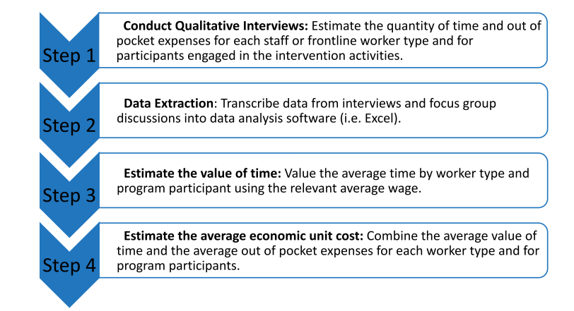
Option 1: Collecting and analyzing economic costs from qualitative data

Step 1. Conduct Qualitative Interviews with implementers, partners and participants.
- Adapt SEEMS Nutrition SII and FGD interview guides to collect data on time use and out-of-pocket expenses from all implementing partners and project participants. Modifications should capture time spent on all program activities and expenses spent by program participants, staff, frontline workers that were not recorded in the financial expenditure data.

Tips for adapting guides:
- List out all main program activities for each cadre (e.g., for frontline workers this may be household visits, community events, and trainings)
- Modify questions to capture all time use components of each activity and potential out-of-pocket costs (e.g., for household visits, this would include travel time to households, time spent in the households of program beneficiaries, costs related to childcare/lodging/transportation)
- Include questions on reimbursement if the project offered this support to frontline workers or other cadres involved in program activities.
- Do not double count. If cadres received project reimbursement, do not include here. Only capture out of pocket expenses that were not reimbursed.

- Examples of SII and FGD interview guides can be found here.
- Use the data collection planning tool to organize the set of data collection instruments you will use by administrative level as appropriate (national, district, etc.) and stakeholder type based on your sampling approach.
- Map all program activities to SEEMS-Nutrition standardized Activity codes.

Step 2: Data extraction
2.1 Preparing data in the field.
- Gather interview notes from the field data collection and process the information from the notes by extracting numerical data.
- If possible, enter data from SII or FGD guides plus notes into an Excel form to standardize information across respondents quickly. The forms should include questions on time spent on all program activities, including activity and travel time as well as out of pocket expenses to cover childcare, food, transportation.
- Review this Excel form and identify any missing or unclear information, so that field researchers can call respondents or interviewers to ask for clarification. Be careful to make sure that numerical units are consistent as you extract data into the form, i.e., minutes or hours (interviews may include data in different units).
- Debrief with the field team to see what emerged through the interviews and what to consider when using the data.

Identify any data outliers such as very high responses to double check for accuracy and potential mistakes. If the data are very noisy (i.e., large spread of values, inconsistencies, etc.) and your sample is small, this process is even more important and would be advantageous to increase your sample size if possible, to ensure that you are gathering average economic costs for a specific group or cadre. Keep in mind the types of characteristics that could lead to variation in economic costs, such as region (i.e., areas or districts more inaccessible to frontline workers that require more travel time) when drawing your sample or considering expansion of the sample (i.e., consider interviewing a greater number of workers in one area versus including members from a different geographic area). These considerations must be based on the characteristics of the intervention implementation such as complexity and context.

2.2. Summarizing raw data to estimate average time and out-of-pocket expenses by respondent type.
The goal of this step is to arrive at estimates of time spent on program activities for each respondent type. We will arrive at these estimates using qualitative data collected in Step 1.
There are two options for extracting and summarizing data based on the qualitative interview or FGD sample size:
- If the sample size is small, the raw data can be extracted and summarized for analysis in Excel using either of these approaches:
1) Each Excel file is used for a different type of respondent (i.e., frontline worker)
2) One Excel file is used with tabs for each respondent type.

- If the sample size is large, extract the qualitative data into an Excel .CSV file. Import the file into a data analysis software such as STATA or R to further clean and summarize the data. Then, export the file from STATA or R back into a summary file in Excel.
As part of data extraction, standardize the average time for the same unit of time for all entries. For example, specify the time in hours or minutes, and specify if per week, per month or per year. Include both participation time and roundtrip travel time. Also, standardize OOP over a specific period: per week, per month, or per year.

Step 3. Estimate the value of time and out-of-pocket costs (OOPs)
3.1 Estimate total economic costs for the whole sample.

Where possible, it will be useful to estimate economic costs by activity by cadre and participants.
- If the sample size is small, incorporate the wage rate or salary information for each type of implementing cadre (i.e., frontline worker, volunteer) or participant. In many cases, an average or equivalent wage or salary will be used to value their time spent implementing or participating in the program, i.e., using a shadow wage).
  - Add the wage rates or salary information for each cadre as a new worksheet tab in the same Excel file in Step 2.2.
  - Use the value of time for each type of implementing cadre and participant type estimated in Step 2.2.
  - Extrapolate the average value of time from the sample to the full project.
- Collect information on the number of each type of worker cadre and number of program participants from project records.
- Multiply the average value of time by the total number of individuals in each cadre and participants.
  - Similarly, calculate the value of out-of-pocket expenses (OOP). Estimate the average out-of-pocket (OOP) cost per cadre or participant (i.e., average OOP per frontline worker, average OOP per woman participant).
  - Multiply the average OOPs for each cadre by the total number of individuals in each cadre. Then aggregate OOPs of all the cadres, volunteers, and participants to the whole sample.

- If the sample size is very large, from the summary file exported into Excel from STATA or R in Step 2, incorporate information on salary or wage rate in a new tab.
3.2 Allocate economic costs to input and activity cost categories. Once economic costs are estimated to the full project, allocate economic costs to appropriate SEEMS standardized inputs and activity cost category codes.
- First, allocate economic costs to inputs:
  - Allocate the value of time to the input ‘Personnel costs’.
  - Allocate the OOP expenses to the appropriate input, i.e., ‘Transportation’, ‘Travel’ or ‘Supplies’.
- Second, allocate economic costs to activities:
  - Refer to the mapping of project activities to standardized SEEMS codes conducted in Step 1 and allocate the value of time spent and OOP on each program activity (as organized in the qualitative guides) to the appropriate SEEMS-Nutrition activity code.
Box 1: An example (from Nepal):
  - We standardized time spent on each activity related to the intervention per month to estimate an average time spent per frontline cadre per month.
  - We multiplied the average time per month by cadre by local wage rates to value the average cadre time. We used mean daily unskilled labor rates to value volunteer and unpaid beneficiary time contributed to the intervention.
  - The valued time was combined with out-of-pocket costs per month to arrive at average economic cost per cadre per month. We scaled this cost to arrive at an average economic cost per cadre per year.
  - We multiplied cadre-level average economic costs with the number of individuals active in each district by cadre, and then summed all economic costs to arrive at total economic cost per year.

Step 4: Combine economic costs with financial expenditures.
See this tool for options on how to combine financial and economic costs.
Option 2: Collecting and analyzing quantitative economic cost data from household or individual surveys

Step 1. Data collection.
- Leverage ongoing surveys or extant data (lower effort)
  - Incorporate questions on time allocation and out of pocket expenditures in an existing baseline, midline or endline survey as part of a process or impact evaluation being used for your program or program evaluation. It is also possible to use electronic questionnaires using REDCAP or other digital options.
  - On occasion, implementing organizations collect their own data that may be relevant to calculating economic costs as part of monitoring and evaluation (i.e., the time contributions of beneficiaries to the program), or a research organization may have collected this type of information as part of an external evaluation of the program. If you can gain access to this data, it can help feed into your analysis. However, it is unlikely that OOPs are collected and available as secondary data, so these costs must be collected in another manner if not available.

- Create your own customized survey module (more effort, can gather greater details and specify to your data needs)
  - Design a questionnaire to capture time spent on program activities and out of pocket expenses. Adapt questions from SEEMS Nutrition interview guides on time use and out of pocket expenses for a household or individual survey. Or see examples of questions in Box 2.

Box 2: Example questions to capture economic costs in a questionnaire:
- How many times per [unit of time] did you participate in a program-related activity (i.e., training)?
- On average, did you incur any expenses to cover transportation to and from the activity (Yes/No)?
  - Please provide the average round trip cost to attend one event per person.
- On average, did you incur expenses to cover accommodation or lodging to participate in an activity (i.e., training)?
  - Please provide the average number of nights stayed in lodging and per night cost to participate in the activity.
- Did you have any out-of-pocket costs related to your participation in an activity?
  - What was the average out-of-pocket cost per event that you incurred?

Box 3. Applied example: electronic survey questions.
Below is an example of electronic survey questions asked to individuals participating in business training workshops in Kenya to increase the nutrient value of their food products. The responses were used to estimate economic costs of time and OOP expenses. Note that expenses are calculated in the local currency (KSH) to facilitate comprehension by respondents during field data collection, however, once calculating total economic costs be careful to ensure that costs collected from various sources are all converted to the same common currency for the final analysis (i.e., U.S. dollar for example). This is particularly important if you want your results to be comparable with other studies that calculate economic costs, most analyses are conducted in USD.
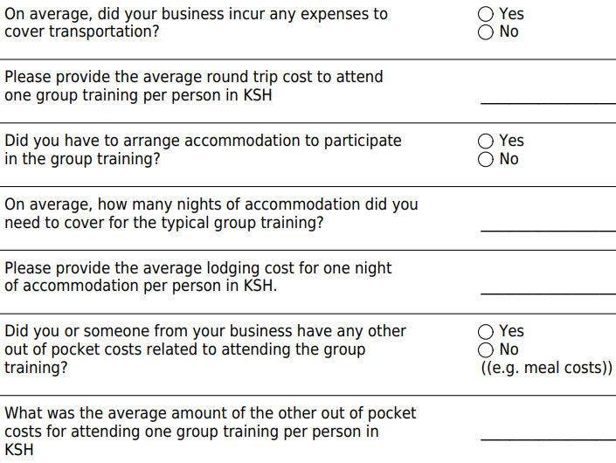

Step 2: Summarizing raw data to estimate average time by stakeholder type.
  - Create preferred file format for Excel or STATA.
- Once the raw data are collected via the survey or questionnaire, download the data to be used in Excel or STATA.
- Conduct regular cleaning and checks (i.e., for outliers) on the raw data to prepare for analysis.

2.2. Summarizing raw data to estimate average time by stakeholder type.
- If the sample size is small, use Excel for your calculations. Create a separate tab in Excel for each type of respondent (i.e., frontline worker cadre) and add a summary tab at the end of the file from which to pull data from your other tabs. Make sure to standardize the average time for a given unit of time (for example, average time per month or average time per year). Check to make sure participation time and travel time are included.
- If the sample size is large, use STATA. Take the Excel file from step 1 to put together a dataset in a csv file and clean data further and summarize in Stata. Then export a cost summary file into Excel.
Step 3. Estimate the value of time and out-of-pocket costs (OOPs)
- If the sample size is small, incorporate salary information (in this case ‘salary’ is an equivalent salary value for the time of this type of worker that is used to value their time investments in the program - see above) in the same Excel file from step 2.
- In the summary tab, calculate the value of time and aggregate it to the whole sample.
- Arrive at an average out-of-pocket cost per unit of interest for your intervention (i.e., per beneficiary, per frontline worker). Unit costs of interest are defined during earlier stages of the costing analysis using the SEEMS economic evaluation framework matrix. Multiply the average OOP for each cadre by the total number of individuals in each cadre, and aggregate OOP costs to the whole sample.
- Add out-of-pocket costs to the value of participant time to estimate economic costs for beneficiaries of the intervention.
- Then, combine economic and financial costs in another Excel file.
- If the same size is very large, from the summary file exported from Stata in Step 2, incorporate salary information in the same Excel file in a separate tab.

Step 4: Combine economic costs with financial expenditures.
- Same approach as in Option 1. See this tool for options on how to combine financial and economic costs.

General guidelines for summarizing economic costs

- Avoiding double counting for frontline workers:
- For household counseling activities, it is important to check if transport time is estimated to the village (or other geographic unit relevant to the intervention) rather than to the individual household. This is to make sure you are multiplying by the correct travel time.
- Be clear when entering or extracting data if the travel time includes more than one activity, so it is not double counted (i.e., if frontline workers do a group meeting and several household visits in the same trip). This should be clearly distinguished in the process of data extraction so that when the next step of summarizing travel time occurs, the time is not entered twice.
- Be aware that frontline workers may be adding additional components to an existing project or to their regular activities, such as household visits. In this case you may want to capture the percentage of time needed for a new component during the household visit, or any additional time needed due to the additional component. Or it could be a completely new visit for the purposes of the project. In that case, count all the time spent as the visit did not exist prior to project implementation.
- This will also affect how you include travel time, and whether you capture the full time of a round trip visit (for new activities) or some share of travel time depending on the percentage of time used for a new component to an existing activity, like a household visit. Verify details surrounding travel time with respondents to avoid inflating travel time estimates.
- One-off events
- One-off events or training workshops usually don’t have a range for time as they only occurred once (i.e., one event took 2 hours). The remaining cells in Excel can be grayed out to indicate that the event only occurred once.

- Frontline worker stipends
- Some frontline workers may receive a stipend from the project and/or from the government. These stipends must be incorporated and considered in the calculation of economic costs for the cadre in question. If time is spent in addition to the worker’s paid working hours (i.e., training after hours or additional time traveling, then those economic costs for time must be considered). If workers do not spend additional time above the paid time, then only out-of-pocket expenditures that are not covered by salary or stipend can be considered.
- Please gray out or indicate otherwise those cells that do not apply to a particular line item, this allows other researchers to understand that data is purposefully not entered (i.e., not applicable) instead of missing.
- Always check to make sure the units are consistent when you are entering them in the summary template (i.e., if you have some data weekly but the sheet has you entering monthly, please enter the original amount in the cell *4 (i.e., for a weekly amount multiplied by four weeks to complete the month) instead of directly entering the total amount). This allows other people to understand which formulas were used and how the summary totals were achieved.

- Estimating travel time to community activities
- Some frontline workers may visit multiple communities or households in a single day. Clarify during interviews (or as follow-up communications, if not clarified during field data collection) that roundtrip travel time included in cost estimates reflect travel time from a base (or office) to the community center or movement between individual communities or households within any given day.

For frontline workers, wage rates or equivalents can be obtained from government, publicly available records or from workers themselves. Volunteer and/or participant shadow wages should be context-specific (i.e. to the country in question, for the participant type - i.e. if the participants are rural households in Malawi, to utilize the wage equivalent for an agricultural worker in Malawi). Variation in wage rates is one input that can be varied for sensitivity analyses to examine how intervention costs could change.

