SEEMS-Nutrition Guidance document: Introduction to the financial expenditures tool and step-by-step instructions
This guidance document has been designed to support in-person training. Users can refer to this document post-training.

Overview of Financial Expenditure tool

First, let’s have an overview of the financial expenditure tool. This Excel-based spreadsheet helps researchers organize and code source data from an organization’s financial records. The reason we code the expenditure data is that it allows us to summarize financial costs by year (each year of program implementation) and by the timing of expenses (start-up or recurrent). In addition, this tool allows us to code line item expenditures to the standardized SEEMS-Nutrition activity and input codes. We have found that organizations generally have similar types or categories of expenditures. However, the way they describe their expenditures is often unique. The SEEMS codes are standardized so that we can compare different interventions even if their expenditures have different account codes and/or labels. The output of this tool is a comprehensive summary that includes cost breakdowns by year, timing, intervention activity and by input category (inputs are the resources used to implement the intervention).
The financial expenditure tool has a set of standard worksheets. Let’s go over the main sheets.

- The cover tab provides step-by-step instructions on how to use the spreadsheet with a detailed description of each worksheet tab.
- The ‘assumptions’ worksheet tab lists assumptions (key suppositions that we hold as true for the purposes of our analyses) for any currency adjustments and assumptions for estimating depreciation for capital costs. Make sure the currency conversion rates are specific to the time when the intervention as conducted (these historical currency conversion rates can be obtained for free from oanda.com)
- The ‘allocation code’ worksheet allows the user to enter the time allocation estimates often obtained from qualitative interviews by type of staff position (i.e., director, coordinator, frontline worker) to SEEMS Nutrition activity codes. This worksheet also allows the user to allocate capital costs to SEEMS Nutrition activity codes. Lastly, we can use the allocation code worksheet to allocate expenses to sectors and to a typology of nutrition sensitive interventions.
- The ‘account codes to input codes’ worksheet allows the user to map each organization’s unique accounting codes to the SEEMS-Nutrition activity codes.
- The ‘expenditure data and coding’ is where all the action is. This is where the researcher can copy and paste an organization’s raw expenditure data. The researcher can use drop-down menus to assign line-item expenses to input and activity categories. This can be done manually, or users can apply simple excel functions to do this more quickly.
- The ‘Base summary’ worksheet allows the user to generate tables and graphs of financial costs by year, timing of expense, SEEMS-Nutrition input, and activity codes.
- The SEEMS Input Definitions lists the standard input definitions. These definitions should never be modified.
- SEEMS Activity Definitions lists standard activity definitions. These can be modified to meet your project’s needs if necessary. Ideally, the researcher will use as many of the relevant SEEMS activity cost categories as possible without modification. This facilitates comparisons with other interventions.

Process for coding expenditure line items
Even though you are doing line-by-line expenditure coding, the process moves in phases.
- The first and easiest phase is to code line items by input cost categories.
- Once you have coded inputs, move on to coding allocation rules which populate activity cost categories.
- Enter data up through column L, which populates the remainder of the columns.

Step 1: Copy and Paste your organization's financial expenditure into the financial expenditure tool

- Import raw expense-level monthly or annual data over the period of the intervention that you are costing into the worksheet Expenditure data and coding Columns A through D.
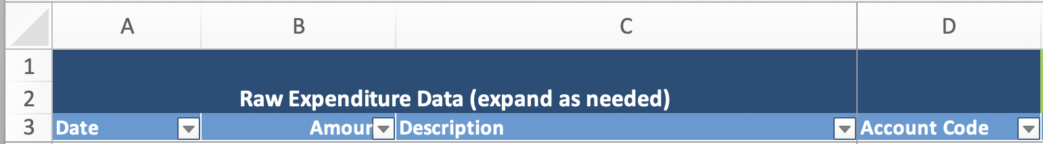
- These columns include the date, expense amount, description of expenses and account code, if applicable.
  - You can insert new columns for raw data if needed, but DO NOT MODIFY COLUMNS A, B, C AND D.
- Import expense report data from the beginning of the project, or period for which you are costing. Usually, you can cut and paste this information directly from the organization’s excel files.
- PRIOR to copying and pasting, you may need to transform the original organization’s data from a different format to copy and paste into columns A, B, C and D.
  - In cases where Account codes (Column D) are not available, please leave it blank.

Step 2: Code expense input types

- If the organization you are costing has project account codes, obtain account codes from the organization’s financial or accounting officer. Use these codes to automate this task by mapping the organization’s accounting codes to SEEMS Nutrition input codes.
- Then, create VLOOKUP tables (an Excel function) that can easily and automatically map the organization’s account codes to the SEEMS Nutrition input codes. Save these VLOOKUP tables to a separate worksheet called ‘Account Codes to Input Codes’
- If the organization has monitoring codes by activity type (i.e., a monitoring code for training), VLOOKUP tables can map those activities to the SEEMS Nutrition activity codes. Save these VLOOKUP tables to a separate worksheet called ‘Account Codes to Monitoring Codes’.
- Here is an example of a VLOOKUP table for input codes. As you can see, the project account codes are in Column A, the original account code descriptions from the organization are in Column B, and column C contains the standardized SEEMS input codes.
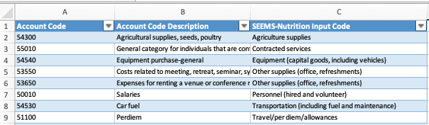
- Code each expense input type using the VLOOKUP function.
- Always be prepared to do some manual coding especially in cases where an account code is missing.
- Use drop-down menus (input by input) or use PIVOT tables to check your work.

If you have qualitative information on time allocation, go to Step 3.
If you have not collected information on time allocation, go to Step 4.

Step 3: Create activity, staff, and capital expense allocation rules
- To allocate expenditure line items to SEEMS Nutrition activity codes, the user must create allocation rules for each broad activity type, staff person type, and capital expense type. In column A of the Allocation codes worksheet tab. We present an overview here, and details below in each step.
  - For each broad activity type, define the allocation rule for allocating expenses to the SEEMS activity codes. The SEEMS activity codes are defined in the SEEMS Activity Definitions tab.
  - For each staff type, define the allocation rules for allocating staff expense line items across SEEMS activity codes, using qualitative data on time allocation for each distinct staff type. Aim to develop a set of distinct staff types. In some cases, you may make assumptions about time allocation for personnel. Make sure to document all assumptions as you go. If you do not document as you go, it is likely you will forget them. This is to ensure consistency in your assumptions as you go through the entire costing exercise. These will be important to include once you present your results or draft reports or publications. As with many aspects of the costing exercise, the additional work up front will save you a great deal of time later and will help avoid confusion once your analyses are complete.
  - For each capital expense type, define the allocation of capital expenses across SEEMS activity codes using the qualitative data you collected.

- Allocating line items to activities, requires two worksheets: the Assumptions worksheet tab and the and Allocation codes worksheet tab that are colored blue. These tabs list assumptions and allocation rules that are linked to drop down menus that assign cost shares from one line item to one or more activity categories.
Step 3.1 Enter or adapt assumptions and allocation rules

- Define assumptions and parameters in Assumptions tab. This includes updating information for the specific currency conversion rates for the country the program was implemented in.
- Enter information into the Allocation codes worksheet tab to create allocation rules for each staff category or intervention activity or capital expense type. What are allocation rules? We explain below:
  - An allocation rule is based on defining a type of staff position (e.g., Head of Office) or category of personnel (e.g, a frontline worker). For each staff type or category, you need to assign the percentage (%) of time allocated to each relevant project activity code. You do this using information you pull from the qualitative data (i.e., the analysis of the data obtained and analyzed from the semi-structured interview (SSI) guides).
  - Similarly, you undertake this same process for each capital expense and intervention activity. For each capital or activity expense type (e.g., Equipment), define the percentage (%) of the total amount of that capital expense across project activity codes. You do so by using information gathered from your qualitative data. For each of these codes, you define whether each capital expense occurred at start-up (e.g., a piece of equipment procured to install a district office) or is a recurrent cost (e.g., procurement of seeds).
  - For any of the staff, activity, or capital expense allocation rules, you may need to also make assumptions for some line-item expenses to inform your allocations to activity categories. Make sure to document all your assumptions.
  - For each of these allocation rules, you also need to undertake this same process for the nutrition-sensitive typology and for the sector it is associated with (i.e., nutrition, health, WASH, gender). Use the intervention typology document for your project to guide your coding along each pathway for the typology allocation (i.e., BCC-related activities along the demand pathway, agricultural activities along the supply pathway).

- Next, after creating an allocation code, define whether the activity is a start-up or is recurrent. See step 3.2 below.

Step 3.2 For each activity allocation rule, indicate whether the activity is a start-up or recurrent activity.

- In the same Allocation codes worksheet tab, make sure to indicate if the activity is a start-up activity or a recurrent activity. The below table identifies typical start-up activities. Most activities that do not fall under the table below are recurrent activities.
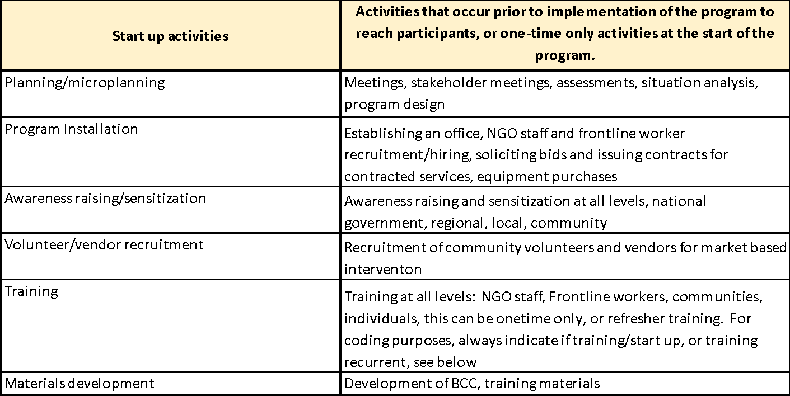

Step 3.3 Add allocation rules for other types of expenses that need to be allocated across activities

- The Allocation codes worksheet tab is a flexible tab that can help to allocate a variety of costs to the SEEMS-Nutrition activity categories. You can enter as much or little detail, as you prefer.
- Example 1. There may be overhead costs that occur during the start-up period as well as overhead costs that are on-going or recurrent. How do you distinguish between these different types of overhead costs? You create two allocation rules: 1) Overhead (start-up) and 2) Overhead (recurrent), as shown below. Both rules will be categorized as ‘Overhead’, but their dollar values will be adjusted to spread ‘start-up’ costs across all years of the project. Recurrent costs will be assigned to the year they were incurred.
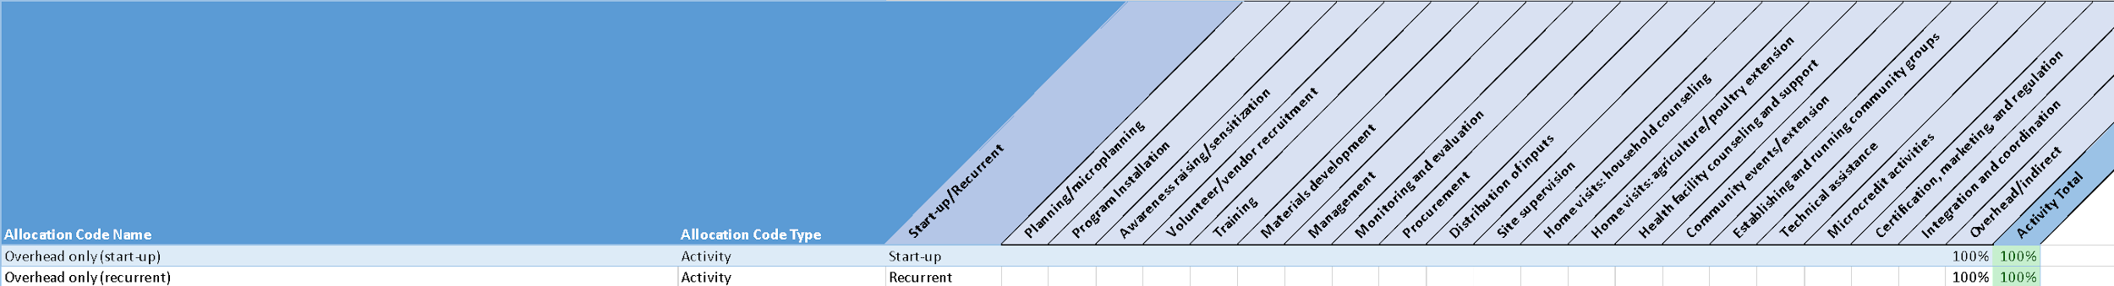
- Example 2. There may be Monitoring and Evaluation costs that apply to both start-up and recurrent cost categories. In this example, M&E start-up costs will be allocated across all years of the project. In contrast, recurrent M&E activities get assigned to the year they were incurred.
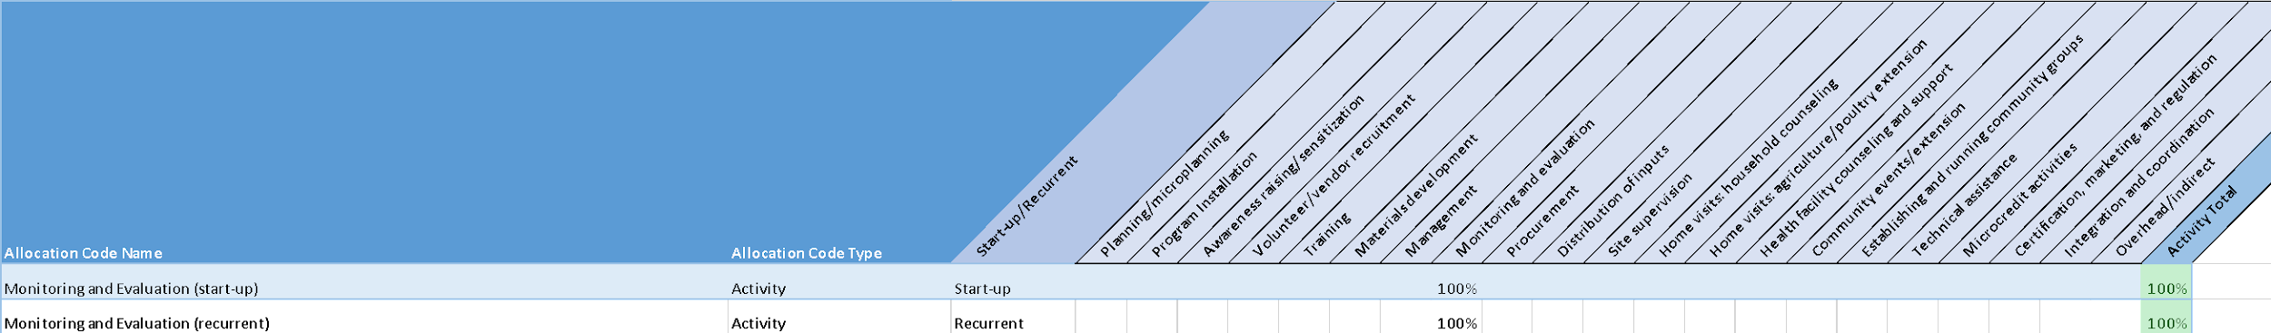
- In most cases, staff costs are considered ‘Recurrent’ costs. However, you could allocate significant and/or large personnel costs to the start-up period. This case would apply if some personnel only participate during the start-up period and then do not continue to work on the project.
- Note that there may be other examples of expense items where you want to distinguish between start-up and recurrent. Examples 1 and 2 above show how to do this.
Step 4. Expenditure Data and Coding for activity cost categories

- Once you have entered the assumptions, you can now return to the main worksheet tab called, Expenditure data and coding. and use drop down menus to select the allocation code in Column ‘I’. Please note that most of the ‘coding’ occurs by using drop-down menus that have been built into the excel file. Once you select allocation codes, the allocation code type will automatically populate.
- By doing this, the excel program will allocate costs to activity categories automatically. For example the program will automatically allocate activity costs to columns AC through AW; it will auto populate the nutrition sensitive typology to columns AX to AZ; and it will allocate to sectors in columns BA to BG.

Step 4.1 Working efficiently in the Expenditure data and coding worksheet tab.

  - Learn to use the features of excel drop down menus to efficiently apply the same codes. It may be helpful to select all the expenses that apply to a particular item. In order to do this, click on the filter arrow beside the Description heading and write in a phrase or word of interest in the SEARCH box. For example, if you are interested in selecting all the expenses related to meetings, write in “meeting” in the SEARCH box to automatically select the expenses that contain meeting in their descriptions.
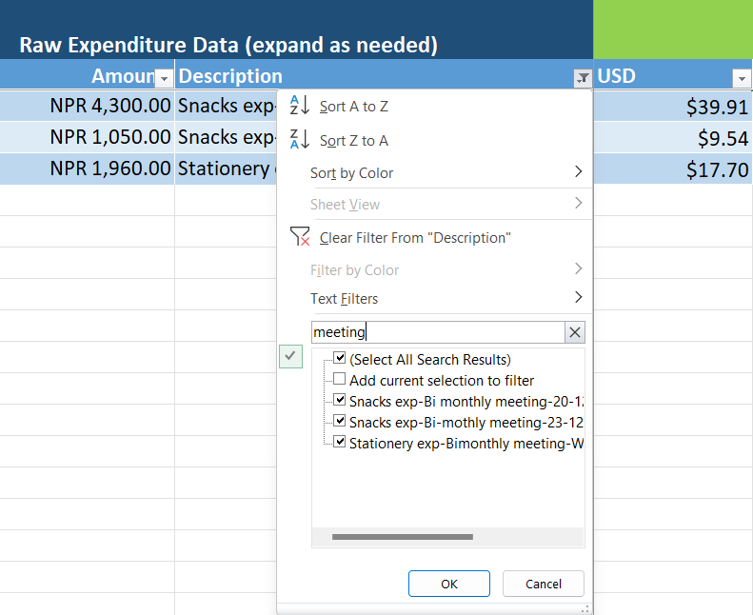

2. Once the desired filter is selected, an allocation code and/or input code can be applied to all the filtered rows. In the example below, if you would like to apply the same input code to expenses with ‘meeting’ in the description: 1) select the appropriate Input code, then 2) drag down the bottom corner of the cell to the last row containing the filtered expenses.
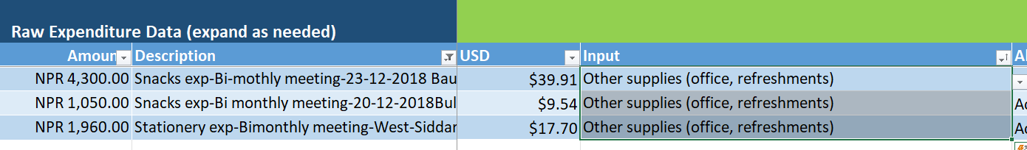
Where we say, “no user input needed”, please heed our advice! The worksheet has many linked cells and adding, deleting, or changing the sheet set-up could result in errors or lost data.

Step 5: Code level and source of expense

- Code each expense based on who had the expense (e.g., the implementing organization) and the level of the expense (e.g., national, district, municipal).
  - Use Column K for ‘Organization’. If you have many implementing partners, create a drop-down menu for coding.
  - Use Column L for administrative level of service. Create drop down menus for relevant levels (National, district, community)

Step 6: Fill in your COVER SHEET

- Remember to go back to your Cover sheet and indicate the date, version, and authors.
- Add your project’s program impact pathways to the cover sheet.
- Clearly describe any additional steps or assumptions to your cost analysis.

Review of the columns in the Expenditure Data and Coding worksheet

BLUE ZONE: RAW EXPENDITURE DATA
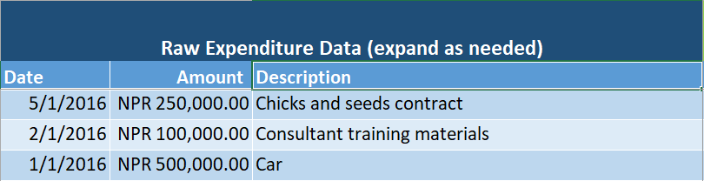
Column | Action
Column A to C | Paste information from the expense reports provided by the implementing organization. Make sure to include date (Column A), amount (Column B), and a description (Column C) of each expense. The amount can be in the local currency.
Column D | If the project you are costing uses account codes to classify expenses, obtain these codes from the organization’s financial officer. Paste them in this column. This information will be used to populate the “Input” column if available.

GREEN ZONE: CODING AND ALLOCATING
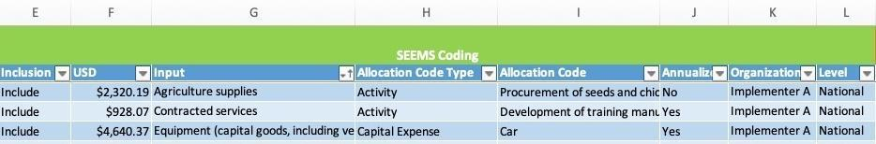
Column | Action
Column E | Code inclusion into the financial analysis (or do not select if the cost should be excluded). Expenses that should be excluded include: activities not directly related to the project, including international travel to conferences or any external research activities not designed to be part of the program (i.e, external evaluation or studies on the project).
Column F | No user input is needed here, it will automatically populate.
Column G | Check that expense input types are correct based on the definitions in the Input definitions tab
Column H | No user input is needed here, it will automatically populate with the allocation code type (activity, staff, or capital expense) pulled from allocation rule
Column I | Assign allocation code based on definitions in the Allocation codes tab. New allocation rules can be created in the Allocation codes tab as necessary
Column J | This column does not require any user input. This populates automatically from the start-up or recurrent designation provided in the Allocation codes tab. Start-up expenses and capital expenses are typically annualized.
Columns K and L | Optional: Code each expense based on who had the expense (i.e., the implementing organization) and the level of the expense (national, district, municipal)

ORANGE ZONE: CODE CHECKS
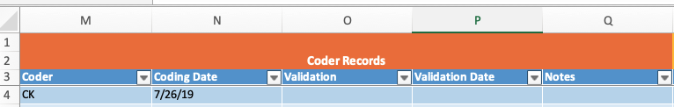
Column | Action
Columns M-Q | Optional: Add your initials and the date of primary coding and validation coding. This is to track who has completed work.
Column R | Check stage codes are correctly assigned for each expense. This should automatically populate once the allocation code is assigned.
Columns R to AW | These columns do not require any user input. They should automatically populate once the allocation code is assigned. However, they should always be reviewed to make sure the allocation rules have been applied correctly.
Columns AX to AZ | These columns do not require any user input. They should automatically populate once the allocation code is assigned. Each expense is coded according to the nutrition-sensitive typology (increase demand of nutritious foods, increase supply of nutritious foods, enabling environment or shared costs).
Columns BA to BG | These columns do not require any user input. They will automatically populate once the allocation code is assigned in accordance with the sector it is associated with (i.e., nutrition, health, WASH, gender).

Dos and Don’ts

- Try not to modify the excel file worksheets, except for the following exceptions:
- DO create your own VLOOKUP tables, as noted in Step 2.
- DO create your project’s allocation codes, as noted in Step 3.1.
- DON’T modify the SEEMS Nutrition input codes. These codes allow for comparisons across projects using the SEEMS Nutrition approach.
- DON’T modify the SEEMS Nutrition activity codes unless your project has a unique and essential activity that is not included in our standardized definitions. Remember that the goal is to maintain standardization across inputs and activities, so avoid adding new activities unless necessary. The more standardized our coding is, the more comparable and transparent your costs will be as compared to other interventions that have been costed using this method.
- Do ADD a new activity code IF IT IS ESSENTIAL. When this is the case, make sure that you update your activity broad categories consistently across the following worksheets:
- SEEMS Activity Definitions (Column A)
- Allocation Codes (Columns H to AA)
- Expenditure Data and Coding (columns AC to AV)

Levin, C., Masters, W;. Gelli, A., Harris-Fry, H., Kadiyala, S;. Kalamatianou, S., Low, J., Puett, C., Skordis-Worrall J., Vosti, S. (2019). Economic Evaluation of Multisectoral Actions for Health and Nutrition. Agriculture, Nutrition and Health Academy Working Group of Economic Evaluations. Innovative Methods and Metrics for Agriculture and Nutrition Actions programme, London.

